https://kenghweetan.github.io/CSCI207ASSN1/

1.0 Introduction

This report discusses the journey that entailed with creating a website for a client with specific

needs and wants. Discussed in this report are the client’s information, initial design ideas, the

design process and the reasons behind decisions made. As the client does not have an initial

website, an interview with the client was conducted to outline the key content in this website.

Also established in this interview are the target audiences for the client, themes and colour

schemes. The transcript of this interview can be seen in appendix 1

## Introduction

This report documents the process and design considerations that entailed with creating a website for a local car rental company specialising in renting electric cars.

Discussed in this report are the aims and objectives of this website, the design process, including the reasons behind particular design decisions. All relevant details on the business model and operational processes have been provided by the client prior to the commencement of the project. Hence, any assumptions would be made based on the information given.

## Aims and objectives

The primary aim of this website is to increase conversions from the target audience of people who are seeking environmentally conscious transport options to becoming customers of AZoom Car rental.

This website will achieve the above in the following ways:

Firstly, by designing a visually appealing and dynamic website that clearly communicates the benefits of renting from AZoom Car Rental.

The website should also establish their credibility as a trusted electric car rental company. This will ideally be communicated to the consumer the moment they arrive at the landing page.

Secondly, by providing a simple and efficient rental journey with minimal steps required to go from the landing page to reserving a car.

Each page should be easy to navigate and have a clear call to action for the user, reducing confusion and subsequent customer dropoff from the site.

## Design process

### Mockup sketches

The design process began with a series of hand drawn sketches that approximated the number of pages required as well as where the content would be laid out within a window (Appendix 1.1). This serves to provide a frame of reference during development of element layout without needing to have all assets in place prior.

### Colours

Next, a series of colours were chosen:

The background was initially chosen to be white during it’s strong reading contrast with dark coloured text (as opposed to the inverse which is more difficult to read), however, during development, the pure white background was found to be harsh and unpleasant to browse for long periods.

Hence, an off white RGB(245, 245, 245) was chosen as it is less harsh while maintaining strong contrast for readability. It also provides a subtle but noticeable separation from pure white elements in the foreground.

For the headings (Appendix 1.2), **RGB(2, 115, 115)** was chosen due to its strong contrast against the off-white background. Meaningfully, the low red, equal blue and green brightness values places the colour as a balance between the blue that is commonly associated with electricity and the green associated with nature.

All main call to actions (Appendix 1.3) were coloured **RGB(216, 104, 0)** to serve as an opposing colour to the heading so as to help separate any call to action and button elements from the other elements on the page, providing an visual guide for the customer’s next step in the rental journey.

The navigation bar and footer (Appendix 1.4) are **RGB(14, 15, 19)** which provides a clear, contrasted separation between the off white background main content of the page and the header and the footer. This helps to serve as a further visual guide for the user to focus on the body of the content instead.

For the dark backgrounds and certain secondary elements (Appendix 1.5), rgb(4, 191, 173) may also be used to highlight certain actions. The weaker contrast visually serves to hint that the action on this element is secondary compared to the primary call to actions.

### Design considerations by page

#### Home page

For the home page, the objective is to make a strong first impression on the prospective user. A video montage of an electric car driving through several environments is shown, its quick movements serving to lend a feeling of dynamism to the website (Appendix 1.6).

In addition, the video is darkened slightly through the use of an translucent background colour achieved through the CSS property “background-colour: RGBA(0,0,0, 0.1)”. This helps to contrast the background overlay against the center elements.

The first center element makes use of a JavaScript function to create a simulated typing animation that displays in sequence the following “Go Fast.”, “Go Far.”, “Go Green.” (Appendix 1.6). This not only further adds to the dynamism and animated feel of the landing page, but also succinctly communicates the benefits of renting an electric car to the audience while keeping their attention as the self-typing words piques their curiosity. The audience can then act on any potential interest by clicking on the “rent now” button below, which is the only coloured button on the screen by design to indicate it as the main call to action of the page. (Appendix 1.6).

In addition, should the user aim to find out more about AZoom, they can scroll down to find information about AZoom’s rates, their aims and goals, fleet partners and reviews from prior customers. The pricing section aims to convince the customer of the AZoom’s benefits such as “equal rates across the fleet” as well as “unlimited miles and insurance coverage” (Appendix 1.7).

The placement of iconic car brands as partners as well as real customer reviews further the as well as bolstering their credibility. through the placement of iconic car brands as partners as well as real customer reviews (Appendix 1.8).

Certain elements like the rental rate cards and reviews have also been given hover interactions through CSS :hover properties to provide the user with subtle ways of interacting with what is otherwise static content. The reviews are also wrapped in quotation icons to represent the authentic opinions of the customer in a stylised and visually appealing way. (Appendix 1.9)

#### View cars

This page serves to help the user quickly find the vehicle that meets their needs. To accomplish this, the following design considerations were applied:

Each vehicle card would consist of an image, a heading containing the vehicle’s name and the vehicle’s seating, storage capacity and range. (Appendix 2.0)

The image of the car would be positioned in such a way that the user can see most of the front and side profiles of the vehicle, helping them quickly form a visual impression of the car without needing to click into the car’s details. (Appendix 2.0)

The car’s name is given the heading colour distinct from the rest of the car’s information so customers can quickly determine each car’s model at a glance, it is also angled slightly to the right at 8 degrees, increasing each card’s visual flair while the larger font size and weight keeps the text easily legible. (Appendix 2.0)

The car’s main specifications are presented as icons with a number at the side as it reduces the amount of text on the card, resulting in a less cluttered page while retaining important information. (Appendix 2.0)

The filter section is also hidden at first behind a button as this prevents the user from being overloaded by too many inputs at once. The button is deemphasised through the use of a outline border with a transparent background. Once the button is clicked, the filter section smoothly slides open through the use of CSS transitions and the button is filled to show its active status. (Appendix 2.1) The filter section consists of a series of checkboxes that lets the user narrow down their preferences by brand, number of seats and vehicle category. (Appendix 2.2)

The buttons to confirm and reset the filters are colour coded according to standard convention of “green” to confirm action and “red” to reset, this helps to visually guide the user to click on the correct buttons without needing to read the text labels although those are still provided for the sake of clarity. In addition, the cards will resize according responsive for usability on mobile.

Each card is also given a hover action where it will increase in size and change the mouse cursor to a pointer to indicate to the user that it is clickable. (Appendix 2.3)

#### Car details

The car details provide more information including additional features and other images of the car in different perspectives as well as allowing the user to begin the booking process here. The images are contained in a carousel that spans the width of the screen, giving it a wide panoramic view on landscape that serves to deliver a strong first visual impression. (Appendix 2.4)

The buttons for next and previous images are given a large clickable area on either side of the image so the user doesn’t have to accurately place their cursor on the arrow symbol to click the button. The area of the button also casts a dark linear gradient on hover to serve as a distinct yet visually appealing indicator that the button can be clicked without blocking the image. (Appendix 2.5)

Jump links are also provided below the carousel should the user wish to view the images out of sequence. The features and booking form are clearly segmented on either side of the screen with their own respective headings, clearly defining the content and intent of each section.

The booking form inputs lets the user quickly decide when they wish to book, which rates they wish to use and the branch they would like to pick up the vehicle from. (Appendix 2.6)

The selected branch also shows a map preview along with an address to quickly inform the user of where the outlets are located. (Appendix 2.6)

As stated previously, the distinct colour of the call-to-action elements helps guide the user towards the next step of the reservation process. (Appendix 2.6)

#### Login/Sign up

Trying to book a car without being logged in will prompt a login/sign up modal to appear (Appendix 2.7). A modal was chosen instead of a separate page as it lets the user perform the required action without interrupting the rental process and increasing the chances of drop off. As a driver’s license is usually required to rent a vehicle, a file input is also provided during sign up for the user to easily upload their digital copy. (Appendix 2.8) The login/signup buttons are also coloured the same as the call to actions to maintain visual consistency.

#### Reservation Summary (Appendix 2.9)

After logging in/signing up, the user is led to the reservation summary page which is pre filled in with information from the previous page and from the user’s account information.

The credit Card input is presented in a form resembling an actual credit card. In addition to visual flair, it also serves as a visual guide for each field input as the form layout resembles a physical credit card, thus reducing the likelihood of form input mistakes. The user can also check the “Save credit card info for future reservations button” for smoother checkouts in future.

Upon clicking the main call to action “Pay using credit card”, a confirmation modal will appear that will present the user with a payment complete message.

This clearly communicates the completion of the reservation process to the user without needing to redirect the user to another page. Furthermore, they can simply return to the main page by closing the modal.

#### Recent rentals (Admin/user)

The user’s recent rentals can be found in their profile page while the admin’s recent rentals is a dedicated page on it’s own. (Appendix 3.0)

This was designed due to the admin more likely needing to check this page much more than any individual customer would, hence keeping it in a separate page lets more rental data be shown.

As the data for recent rentals is tabular, it is best presented in a html table. To help users more easily identify which row’s values they are currently at, a subtle expansion and box shadow was added to the row on hover. (Appendix. 3.1)In addition, a coloured circle that changes based on the status of the rental helps to quickly communicate the rental status to the admin/user so they can follow up with either the final payment or vehicle inspection. The main difference between the recent rentals for user and admin, is that the admin sees all recent bookings while the user only sees their own bookings.(Appendix 3.2)

#### Inspection/Invoice page

To assist in creating the final invoice, a vehicle inspection form is included, but not open by default as rental cars returned with additional damage is assumed to be less frequent than returns without. (Appendix 3.3)

A large button is included to expand the inspection form and it is coloured differently from the main button to send the invoice/pay the final bill to visually communicate that these two buttons serve different roles on the page. (Appendix 3.4) The inspection form makes it convenient for the user as instead of needing to upload an external file.

They can simply mark the spot on the vehicle and a table row is automatically added to the table for them to fill in the damage and cost. All damages are then automatically calculated into the total cost to be sent to the user. The user would then check for their invoice in their recent rentals. They would be able to view the invoice in the same format with the exception that the inspection form cannot be edited and they would be presented with an option to pay. Animated Dialogs would be generated upon invoice sent and payment made, helping communicate the successful operation to the user. (Appendix 3.5)

Appendix 1.1 Prototype sketches

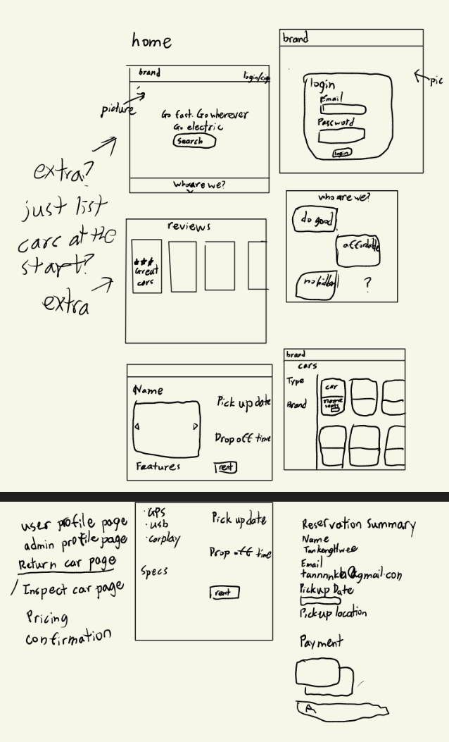

Appendix 1.2 Examples of Headings colour



Appendix 1.3 Example of Call to actions colour

 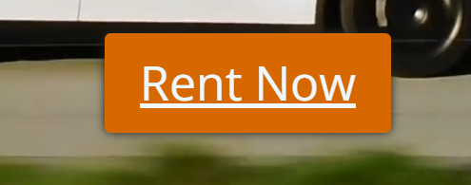

Appendix 1.4 Footer

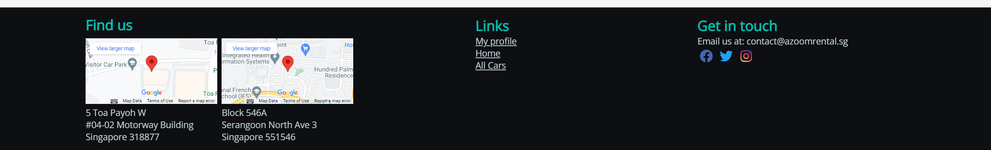

Appendix 1.5 Example of secondary elements



Appendix 1.6 Video overlay of landing page

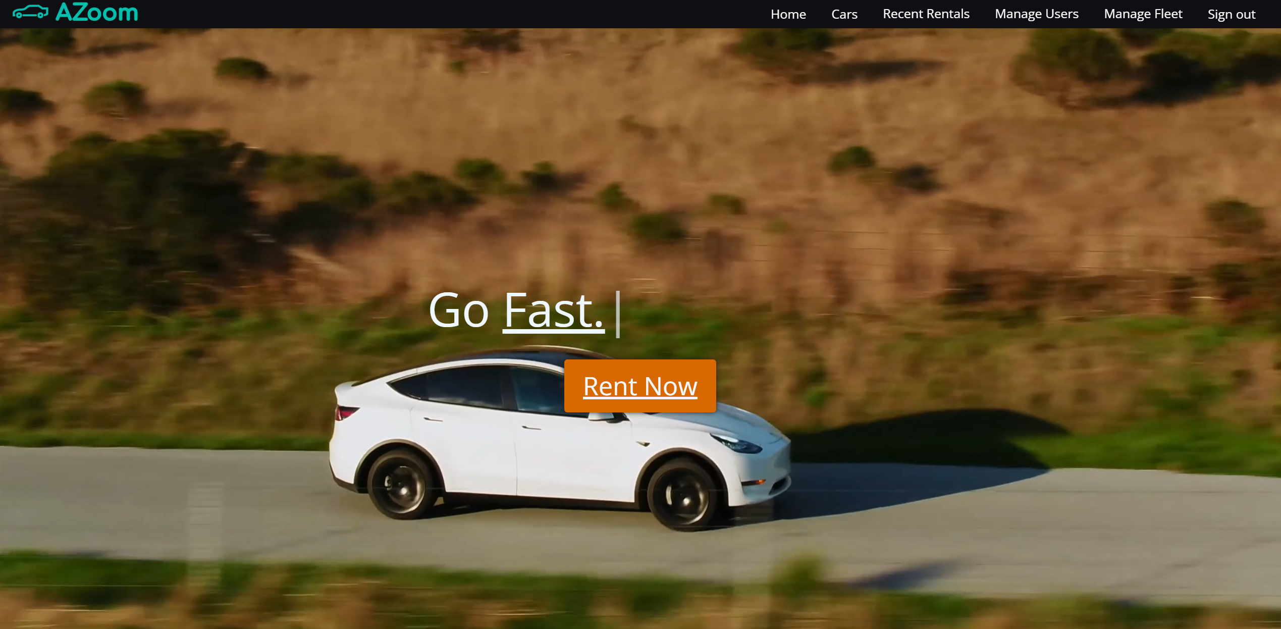

Appendix 1.7 Pricing section

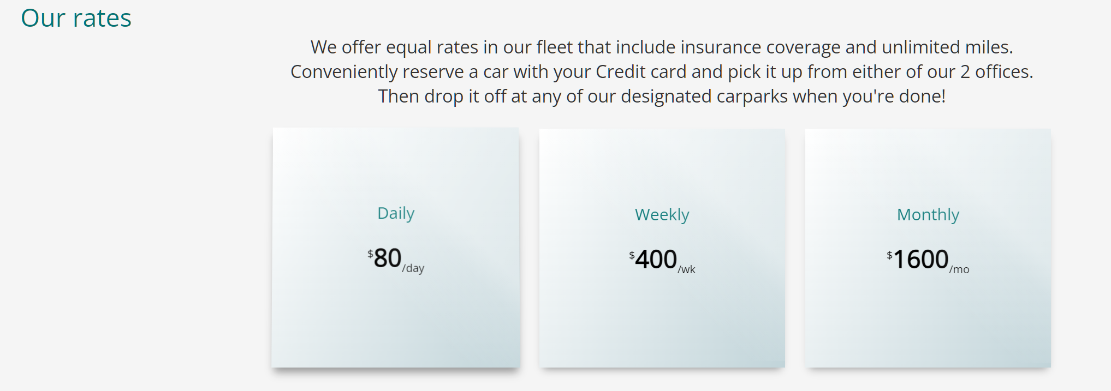

Appendix 1.8 Fleet partners and reviews section



Appendix 1.9 Hover effects of reviews and pricing

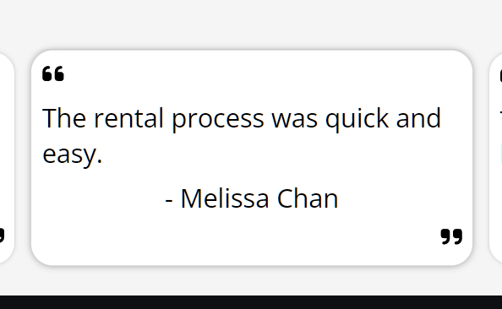 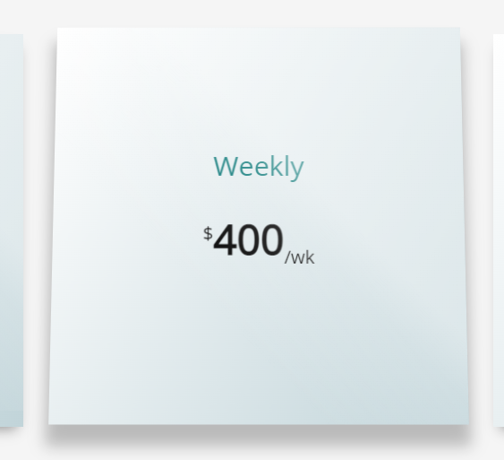

Appendix 2.0 Example of car listing card

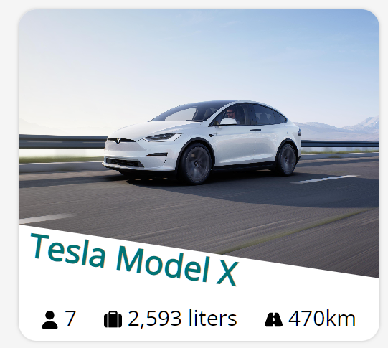

Appendix 2.1 Filter close and open states



Appendix 2.2 Filter checkboxes

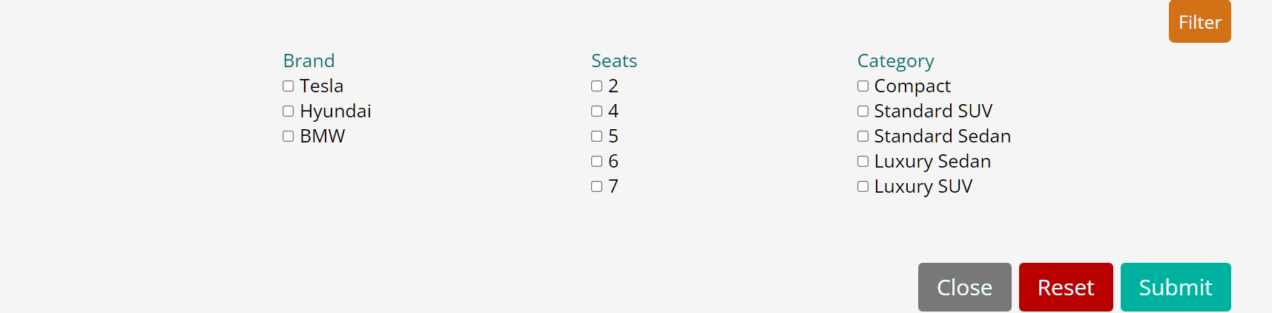

Appendix 2.3 Card hover states

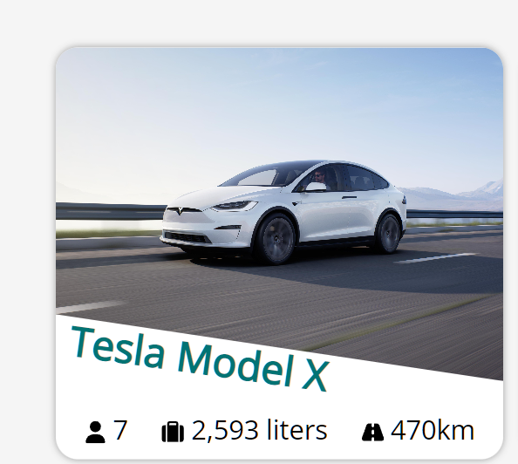

Appendix 2.4 Carousel

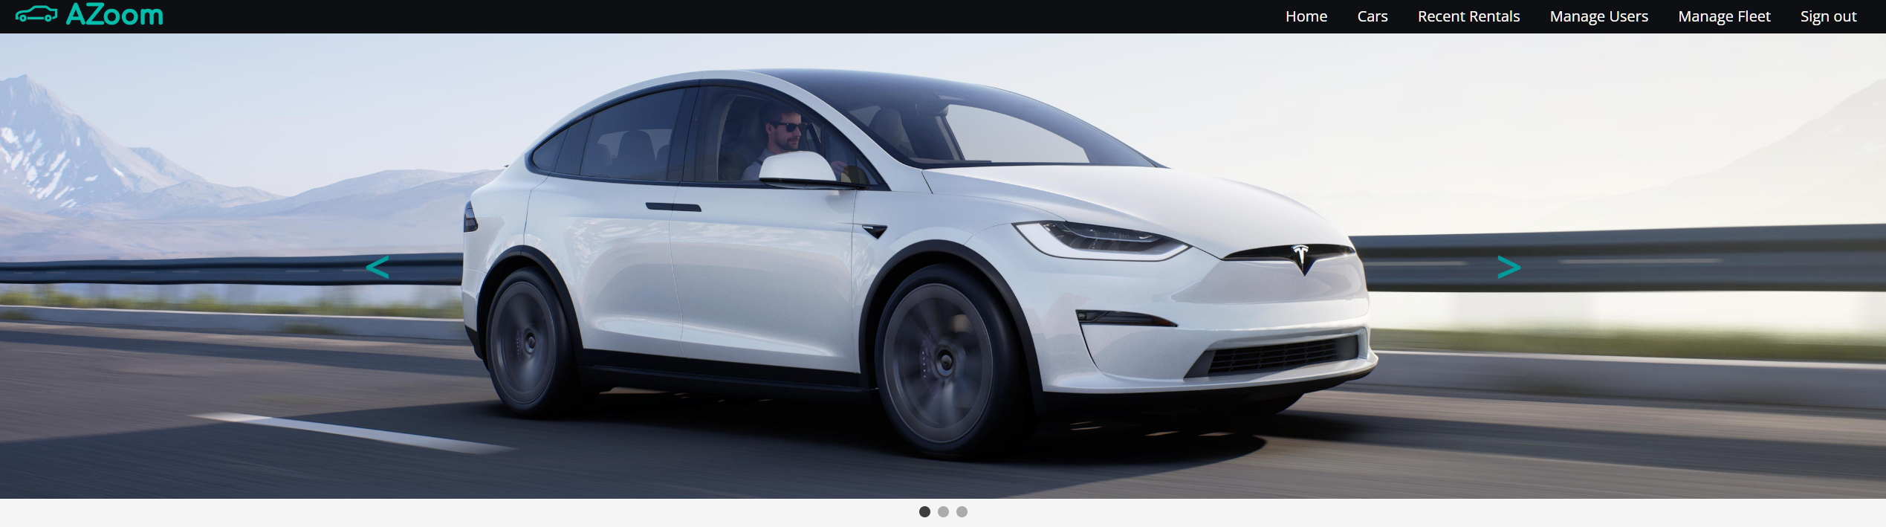

Appendix 2.5 Next picture button hover state

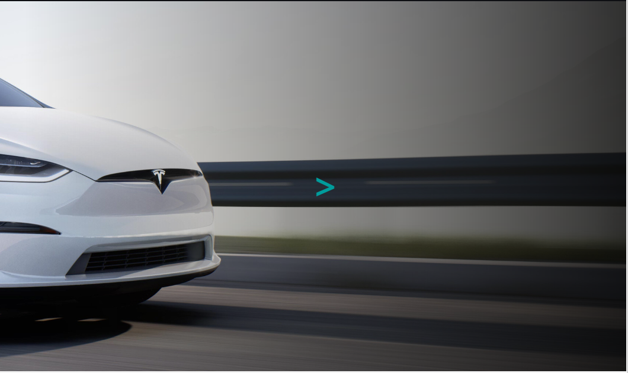

Appendix 2.6 Booking form

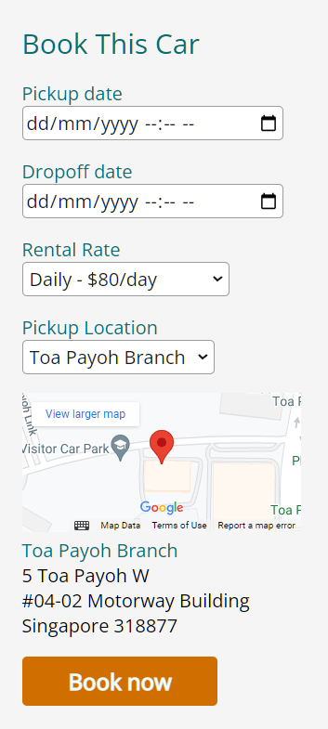

Appendix 2.7 Login modal appearing upon booking without being logged in

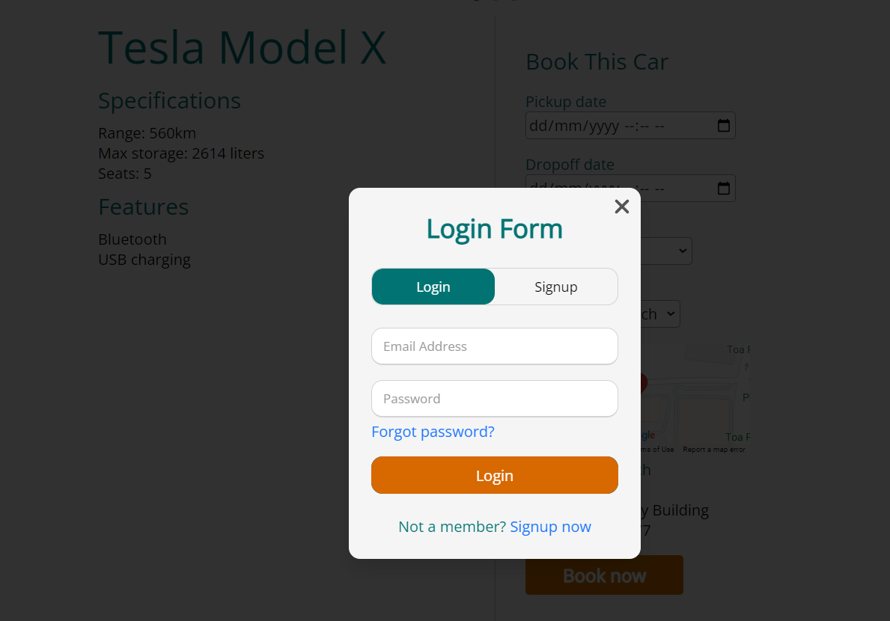

Appendix 2.8 Sign up form with driver’s license input

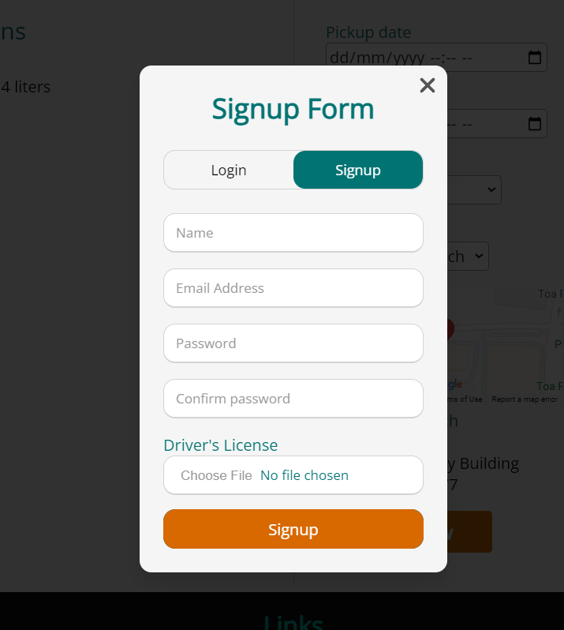

Appendix 2.9 Reservation summary form

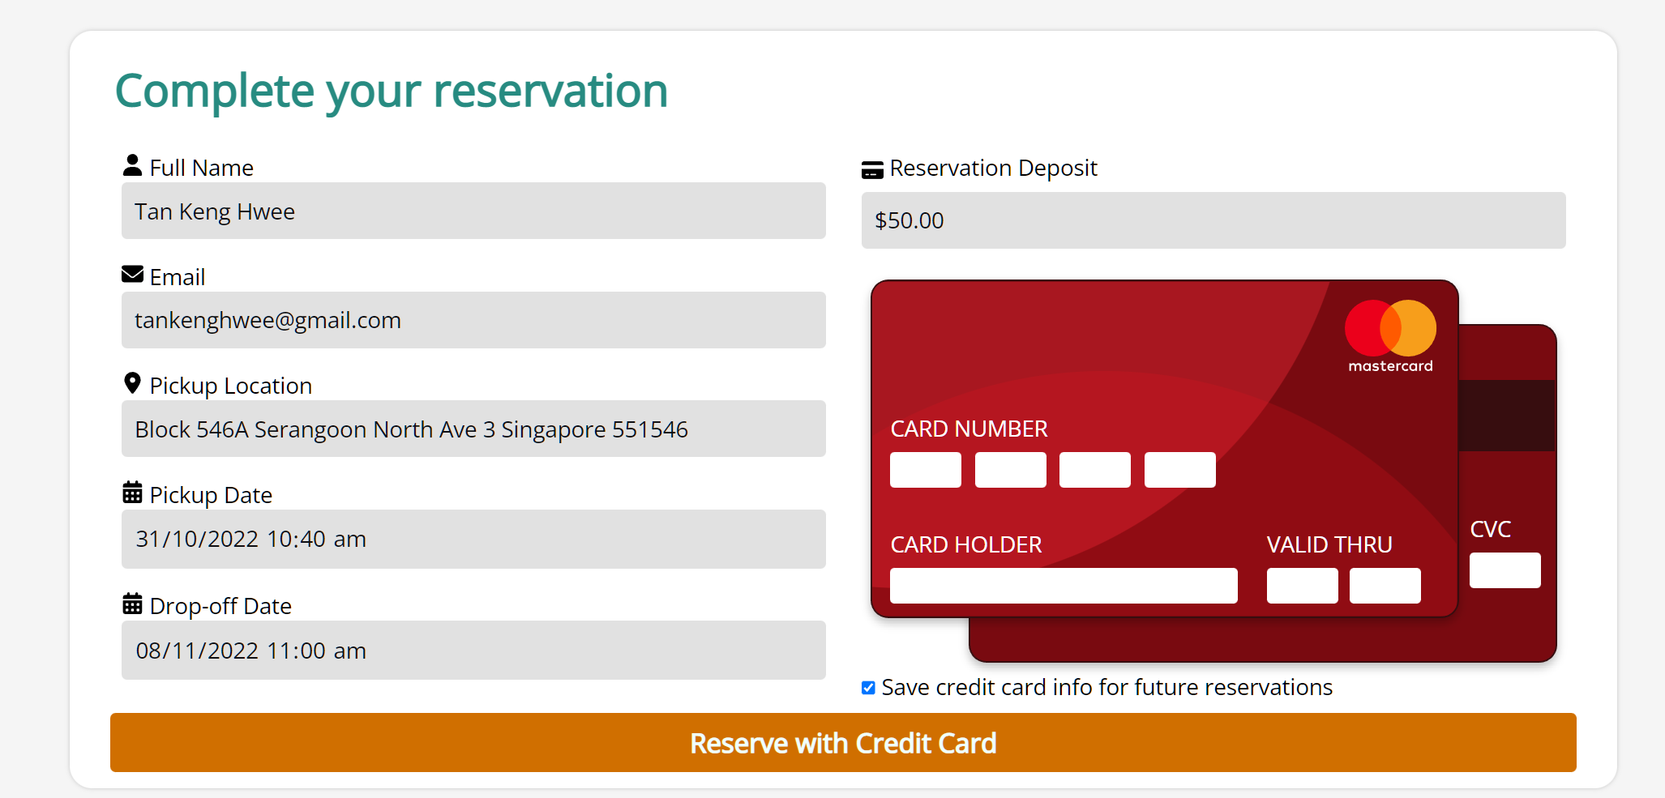

Appendix 3.0 Recent Rentals for user and admin

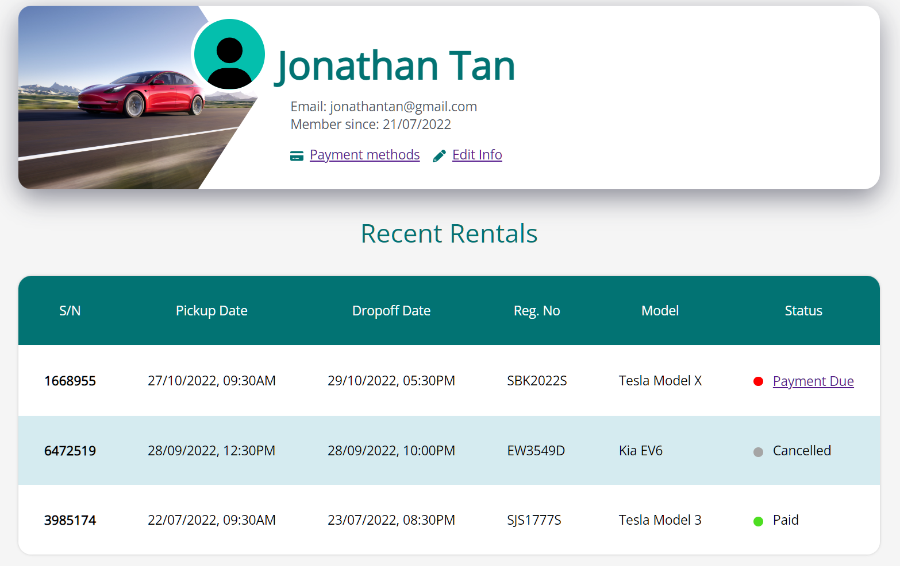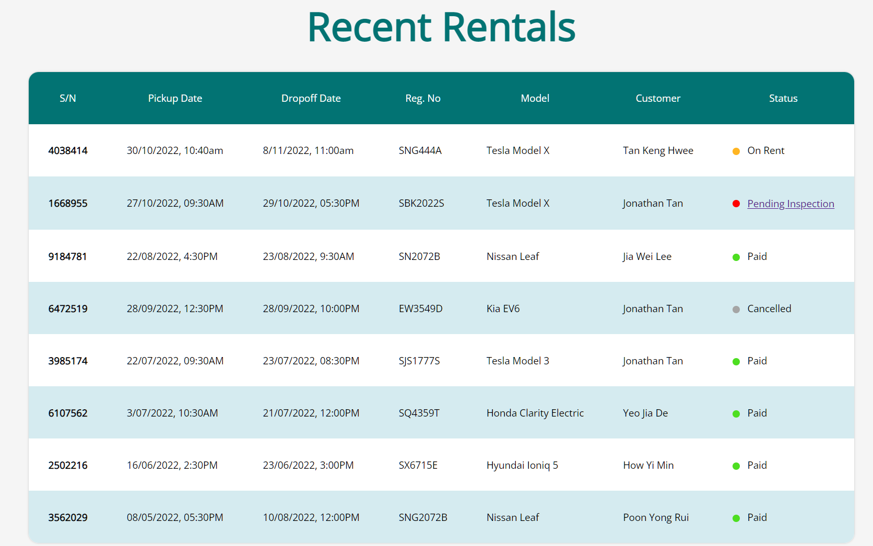

Appendix 3.1 Table hover state

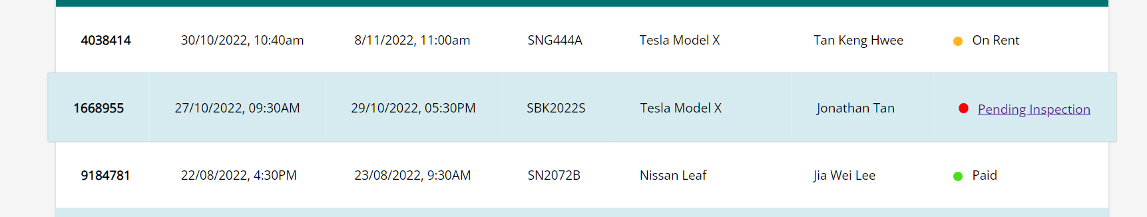

Appendix 3.2 Coloured circles to represent rental status

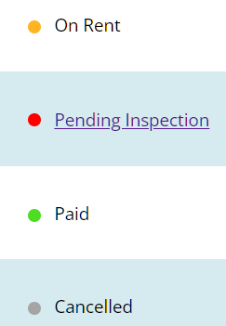

Appendix 3.3 Rental invoice with vehicle inspection form closed

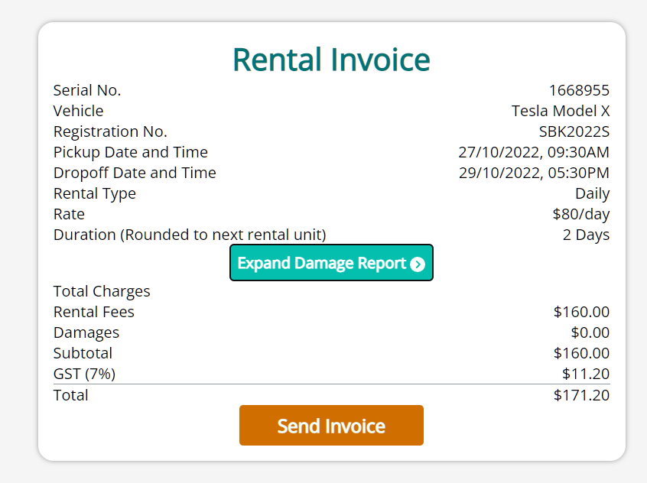

Appendix 3.4 Rental invoice with vehicle inspection form open

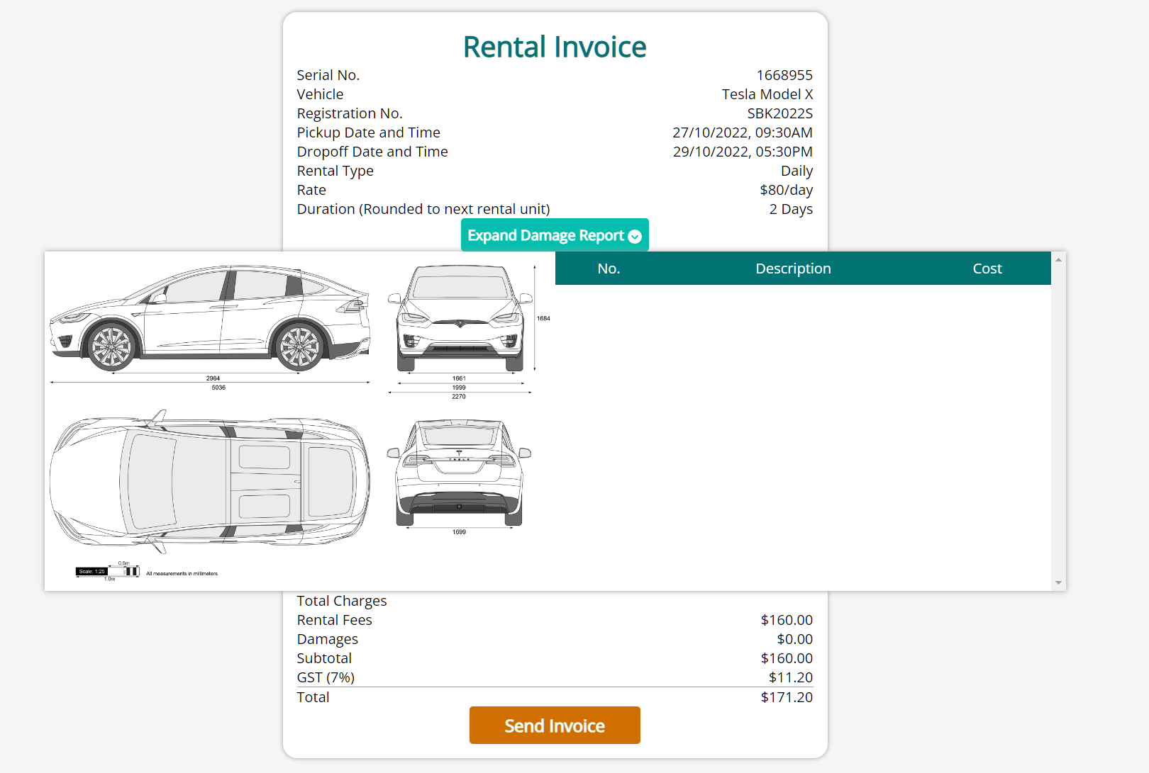

Appendix 3.5 Invoice sent confirmation msg and payment made dialogs

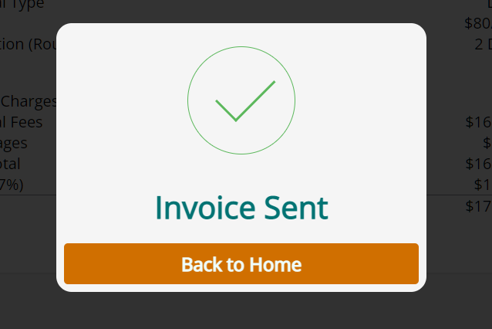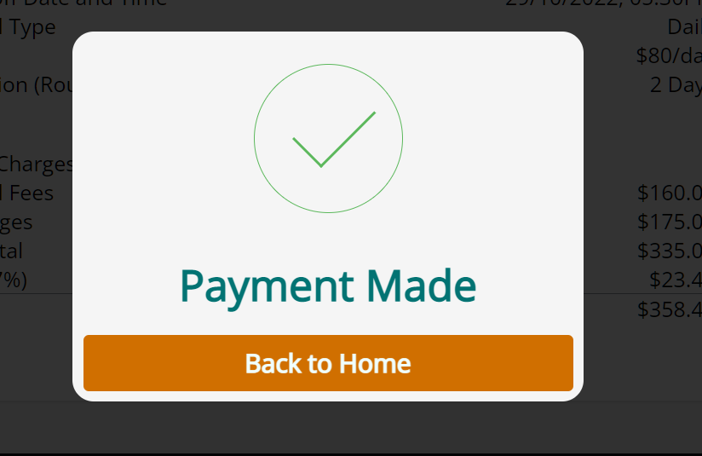

Appendix 3.6